**ASSIGNMENT – 1**

**(module-1)**

1. **What is SDLC?**

* SDLS is structure of imposed on development of a software product defines the peocess planning ,testing , documentetation , maintenance.
* SDLC means “ software development life cycle”.

1. **What is agile methodology?**

* Combination of iterative and incremental process models with focus on process adaptively.
* This method break the product into small incremental builds.

1. **What is SRS?**

* SRS means A software requirement specification is complete description of the behavior of the systemto be developed.

1. **What is OOPS?**

* OOPS is Object Oriented Programming system.
* Identifying project and assigning responsibility to these object.

1. **Write basic concept of oops**

* Six types basic concept.

1. Class
2. Object
3. Inheritance
4. Encapsulation
5. Polymorphism
6. Abstraction
7. **What is object?**

* Object means instences of an class.
* To access all properties of an class but not access private.

1. **What is class?**

* Collection of data member(variable)and member function(process, method).

1. **What is encapsulation?**

* Wrapping your data in single unit it is called encapsulation.

1. **What is inheritance?**

* Properties of parents class extende to child class.

1. **What is polymorphism?**

* Ability to take one name having different foams.
* Main purpose reusability and extendsiblity**.**

1. **What is RDBMS?**

* Relationship Database Management System**.**
* It is DBMS in which the database is organized and accessed according to the relationship between data items.

1. **What is SQL?**

* SQL menas domestic specific language used in programming and designing for managing data held in Relational Database management system.

1. **Write SQL command**

* Four type SQL command.

1. DDL : Data definition language.
2. DML : Data Manipulation language.
3. DQL : Data Query language.
4. DCL/TCL : Data /Transactional control language.
5. **Draw use case on online book shopping**

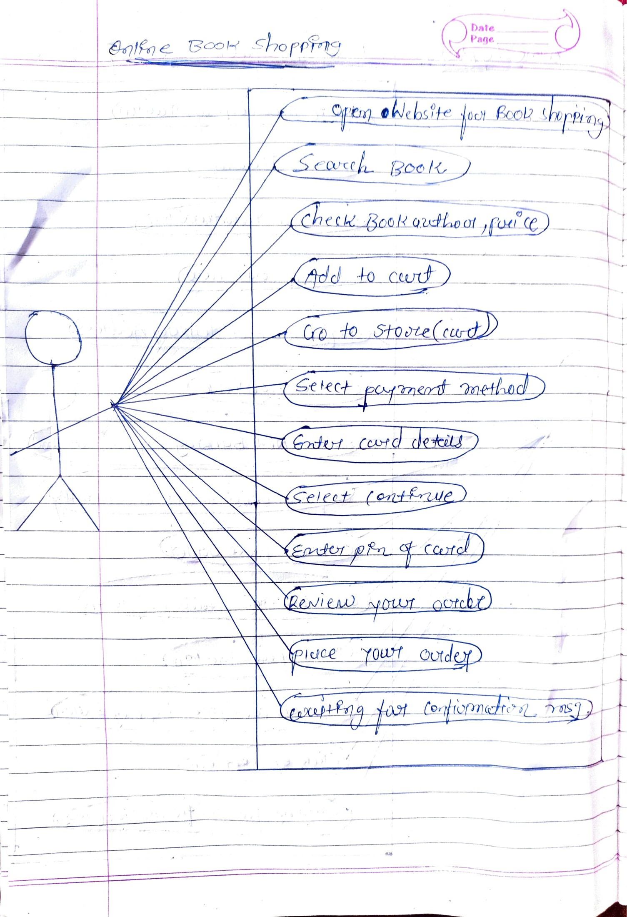

1. **Draw use case on online bill payment system.**

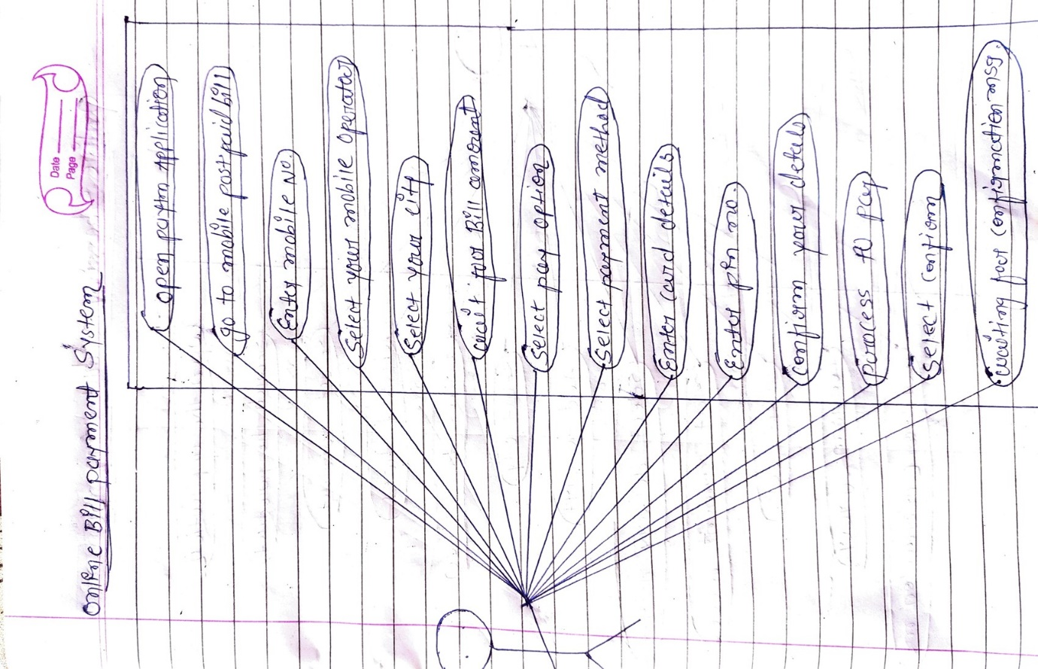

1. **Write SDLC phases with basic introduction**
2. Requirement collection :-

-usage scenarios,

- requirement will change

- plan of change, early prototype.

1. Analysis :-

* define problem that the customer try to solve.
* Architecture define component their interface.
* iii) Design :-
* Design architecture document
* Implementation plan
* Performance analysis
* Test plan

1. Implementation:-

-Give architecture document from design phase & requirement document given by analysis phase the should be build exactly what has been re quired.

v) Testing :-

- Stated quality is important

* Regression testing
* Unit testing
* Application testing

-Stress testing

vi) maintenance :-

- One of activities of software enginnering & is the process of enhacing & optimizing deployed software as well as fixing defects.

1. **Explain phases of waterfall model.**

i)Requirement collection :-

-usage scenarios,

- requirement will change

- plan of change, early prototype.

ii)Analysis :-

* define problem that the customer try to solve.
* Architecture define component their interface.
* iii) Design :-
* Design architecture document
* Implementation plan
* Performance analysis
* Test plan

1. Implementation:-

-Give architecture document from design phase & requirement document given by analysis phase the should be build exactly what has been re quired.

v) Testing :-

- Stated quality is important

* Regression testing
* Unit testing
* Application testing

-Stress testing

vi) maintenance :-

- One of activities of software enginnering & is the process of enhacing & optimizing deployed software as well as fixing defects.

1. **Write phases of spiral model.**

* Spiral model is very widely use in software industries.
* For medium to high risk.
* Customer not their sure requirement**.**
* **Pros of Spiral model:-**
* Changing requirements can be able.
* User see system early.
* Allow start prototype early.
* **Cons. Of spiral model:-**
* Management is hard.
* Process is complex.
* Not suitable for small project**.**

1. **Write agile manifesto principle.**

**Ans .)**

1. **Individual and interaction :-**

* Self organization and motivation are important.

1. **Working software :-**

* Demo software best means of communication with customer to understand their requirements**.**

1. **Customer collaboration :-**

* Requirement not complete in the starting .
* Project due to various factor continuous customer interaction is very important to get proper product requirements.

1. **Responding to change.**

* Agile development is focused on quick responses to change and continuous development.

1. **What is Join?**

* A join clause is used to combine rows from two or more tables , based on related column between them.

1. **Write types of Join.**

* i) inner join
* ii) left (outer) join
* iii)right (outer) join
* iv) full (outer) join

1. **Explain working methodology of agile model and also write pros and cons.**

* Agile SDLC model is a combination of iterative and incremental process models with focus on process adaptability.
* Customer satisfaction by rapid delivery of working software product.
* Agile Methods break the product into small incremental builds.
* These builds are provided in iterations.
* **Pros:**
* Is a very realistic approach to software development.
* Promotes teamwork and cross training.
* Resource requirements are minimum.
* Suitable for fixed or changing requirements
* Easy to manage.
* Gives flexibility to developers
* **Cons.**
* Not suitable for handling complex dependencies.
* More risk of sustainability, maintainability and extensibility.
* There is very high individual dependency, since there is minimum documentation generated.

1. **Draw use case on online shopping product using COD**

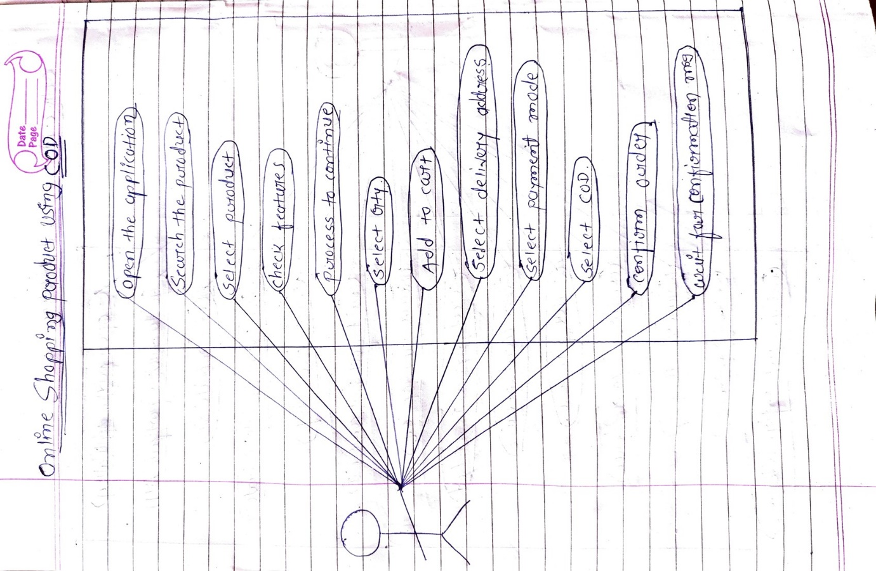

1. **Draw use case on online shopping product using payment gateway.**

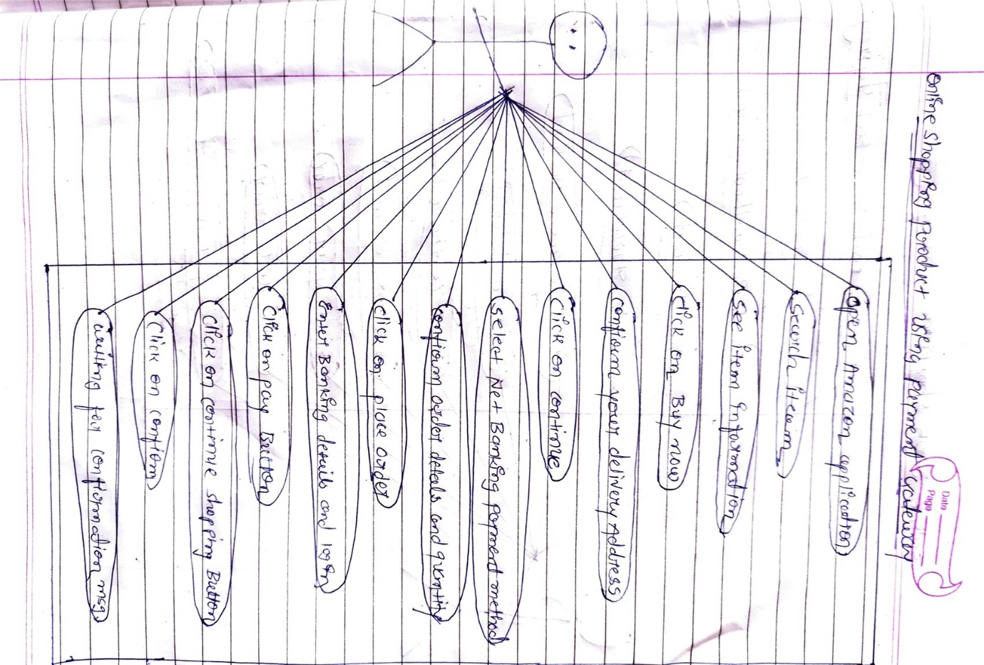

***Thank You***

**From, Raj Bataviya**